Configuring & Using IIS Express
The laboratory workstations should already have this software available. A download link has been provided on Moodle for you to install the latest version on your own computer.
Operating System Required: Windows 7 SP1 (or above)

Mac users may choose to explore XAMPP as an alternative solution. Please refer to “Moodle Resource Links (Relevant Software)” for a list of safe download links.
Step 1: Run the IIS Express application.
- Open a Command Prompt session with “administrator” privileges.
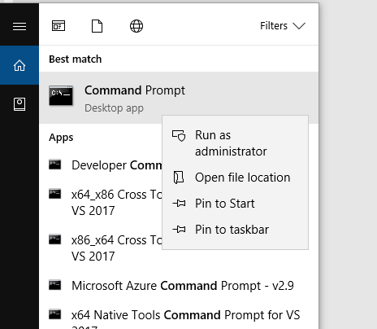
- Type the command that has been highlighted below and then press Enter.
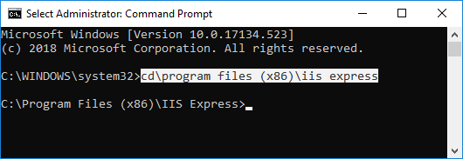
This will make the contents of the IIS Express folder accessible.
- Type the command that has been highlighted below and then press Enter.
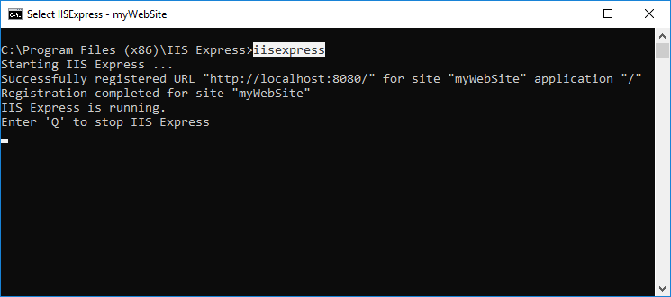
This command will start the IIS Express application and will also create a configuration file the first time it is launched. We will edit that configuration file in Step 3 of this guide.
- Press Q to stop IIS Express and then close the Command Prompt session.
Step 2: Create a folder for your website and download the test.html file.
- Create a folder named DPIT128 (preferably on a USB flash drive). Please refer to the A and B indicators below for the steps involved with this task if required.
A
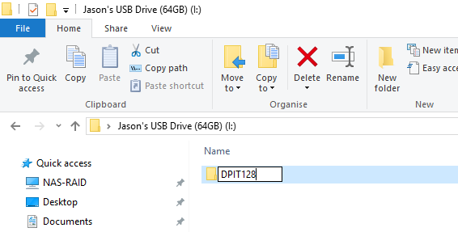
B
- Access the test.html file and then save it into your DPIT128 folder. Please refer to the Parts 1 & 2 indicators below for the steps involved with this task if required.
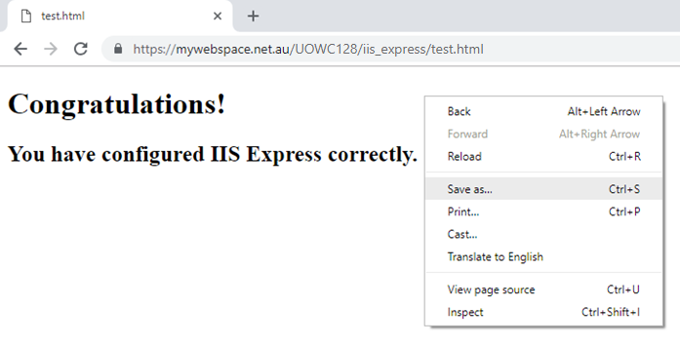
A
B
1

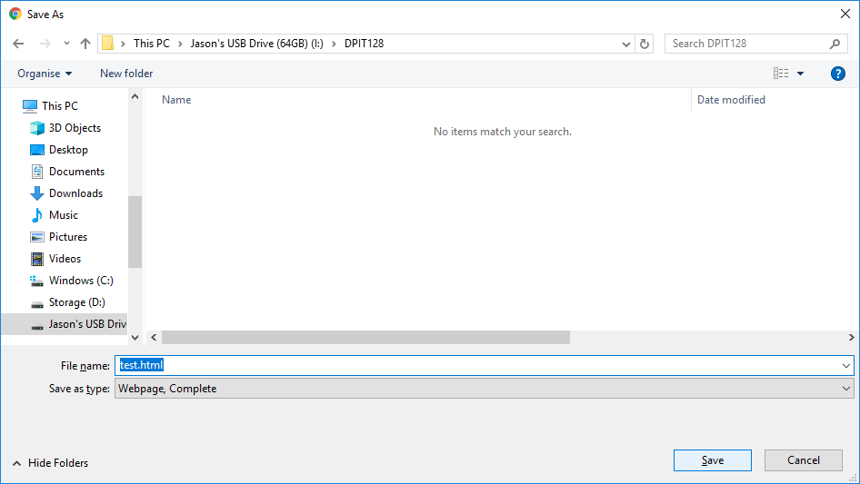
A
2
B
C
You should now have a file named test.html stored within your DPIT128 folder. Please ask your teacher if you require any assistance with the procedures up to this point.
We will soon be ready to use IIS Express to access this file via the http:// protocol instead of the local file:// mode.
Step 3: Edit the IIS Express configuration file.
- Navigate to the config folder as shown in the image below (see A indicator).
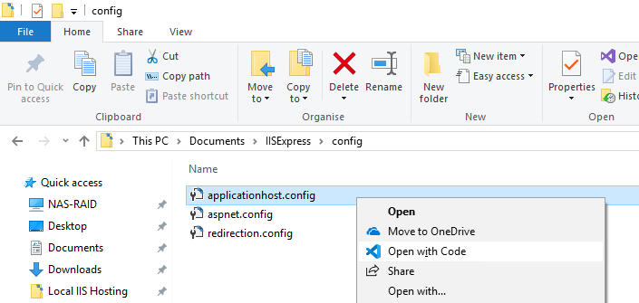
B
A
- Right-click the file named applicationhost.config and select Open with Code from the menu that appears (see B indicator above).
This will open the file for editing. The only values we need to adjust are located on lines 156, 158 and 161. As shown below, Visual Studio Code displays the line numbers for each file on the left side of the interface.
- Change the existing values on lines 156, 158 and 161 to those indicated below. Please be sure to set the physicalPath value (see B indicator below) to the location of the folder you created during Step 2.
A
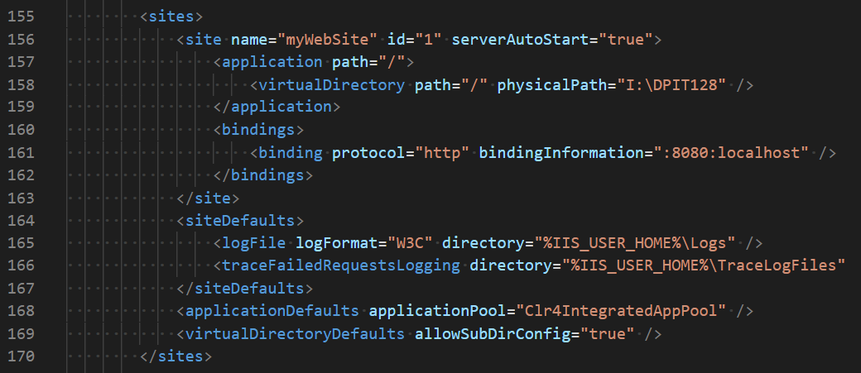
C
B
- Save the file to commit your changes and then close the Visual Studio Code program.
You’ve done it! You are now ready to access your copy of the test.html file.
Step 4: Run the IIS Express application and load the test.html file.
- Repeat Step 1 but this time do not press Q and do not close the command prompt.
- Open your preferred browser and type http://localhost:8080/test.html into the address bar located at the top of the interface (see A indicator below).
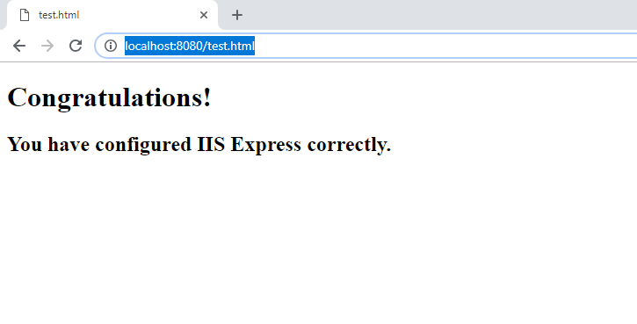
A
Your copy of the test.html page should now load in the browser. The result should appear exactly as shown above.
We will discuss the reasons for using IIS Express during our laboratories.
Version 1.0 by Jason Rodriguez

